MACH4METAL

metalworking machinery
Transito 21, 6909 DA Babberich, Netherlands
Tel. + 31 (0)316 – 247123
Fax. + 31 (0)316 - 247956
info@mach4metal.com
www.mach4metal.com
Bank No : 66.52.13.883
IBAN : NL33 INGB 0665 2138 83
BIC : INGBNL2A
VAT : NL 815393635B01

DAEWOO PUMA 10 S CNC Lathe

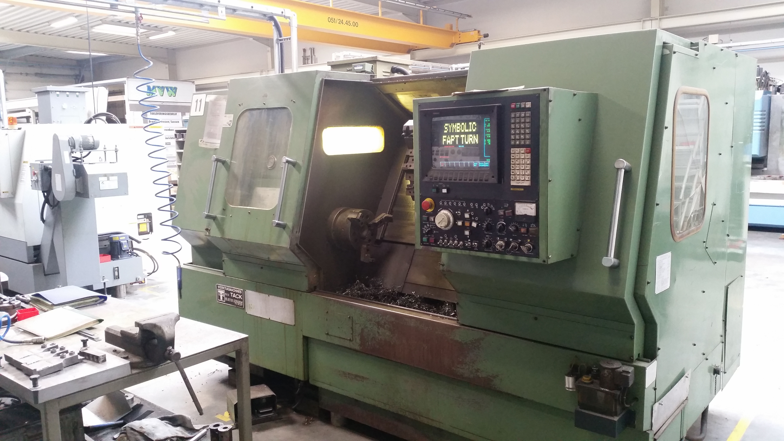
- Make : Daewoo HEAVY INDUSTRIES LTD
- Type : PUMA 10 S
- Age : 1989
- Mach. s/n :

- Swing over bed : 580
- Swing over carriage : 350
- Max. turning length : 770
- Spindle bore : 77
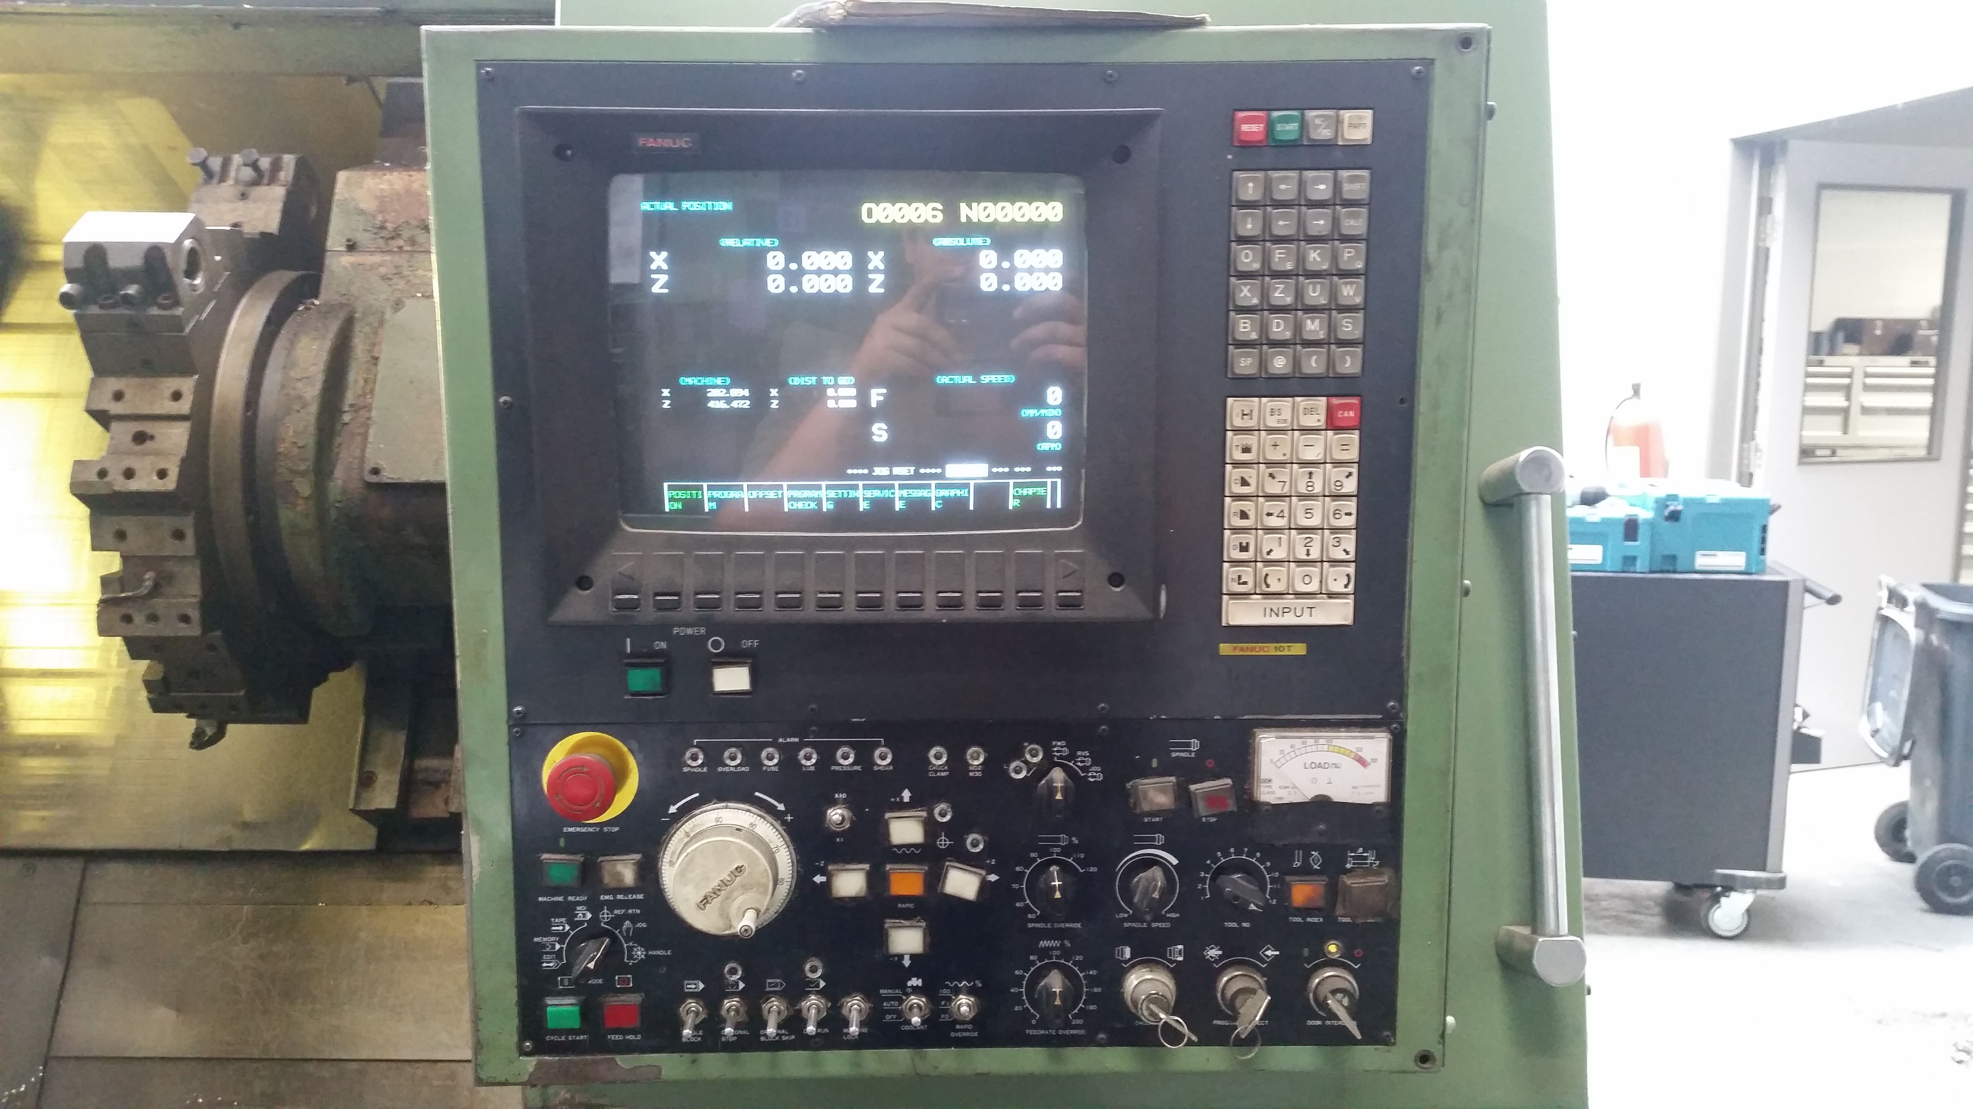

- Spindle speeds : 20 – 2500
- Saddle guide way : 450
- Tailstock guide way : 310

- X Axis travel : 200 mm
- Z Axis travel : 800 mm
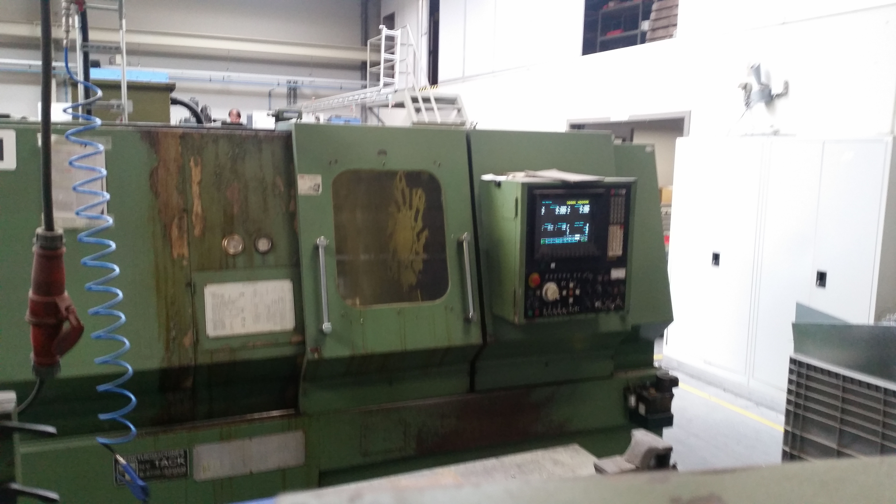
- X Axis rapid feed : 5.000 mm/min.
- Z Axis rapid feed : 10.000 mm/min.
- Turret head : 12 Positions

- Quill diameter : 110
- Stroke quill : 100
- Taper : Mk4
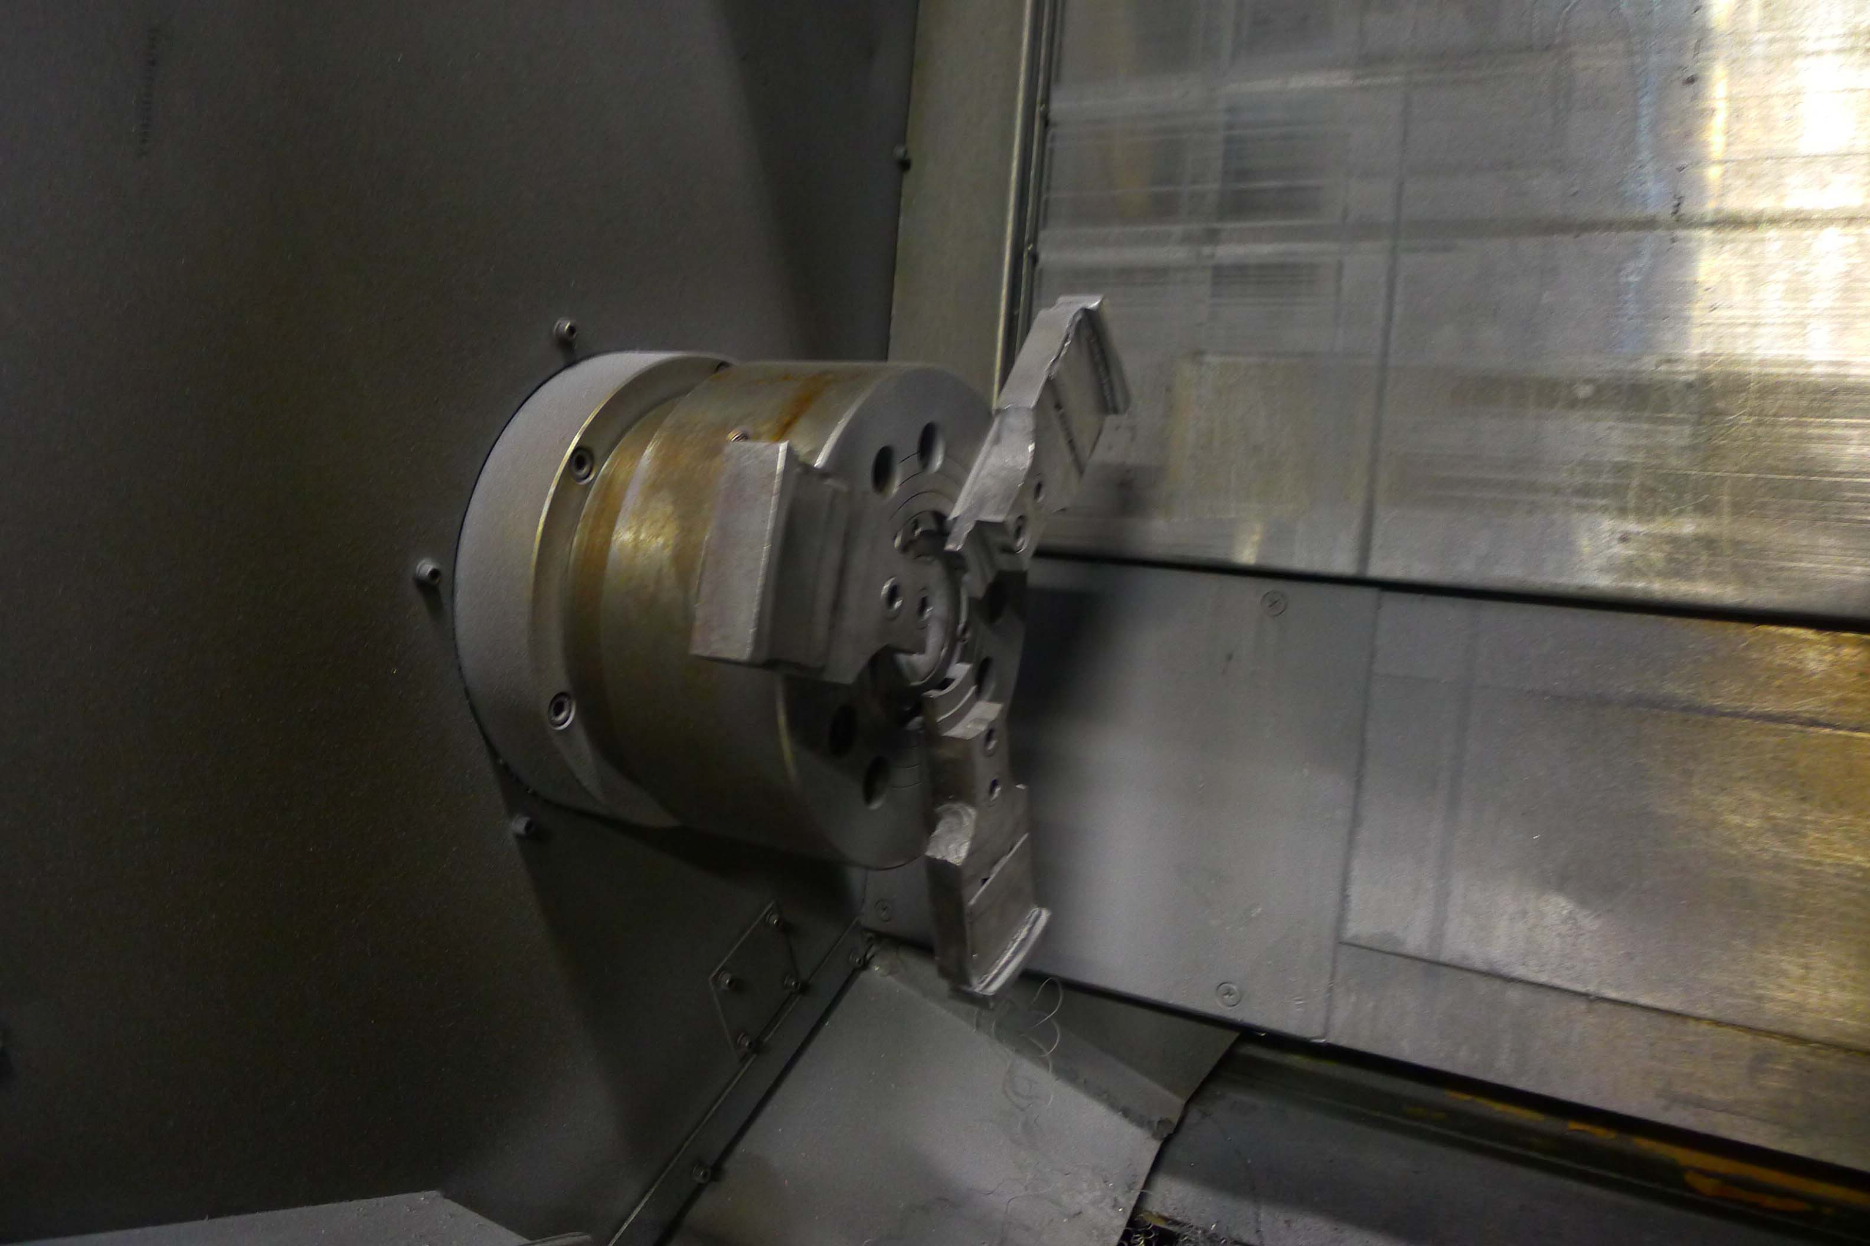
- Dimensions
- Length : 3.175
- Width : 2.080
- Height : 2.000
- Weight : 5.750 Kg

- CNC FANUC 10 T CNC
- Incl. 10 set off jaws

Please Note: The above information has been obtained to the best of our ability and belief from, and from the manufacturers where possible. It is given in good faith, but its accuracy can not be guaranteed. Accordingly, it will not form a representation or constitute contractual terms. We advise you to check any vital details!

